**Vanier College**

**Computer Science Department**

**420-320-VA Database I**

**Fall 2018**

**Lab/Assignment Number and Title:**

Assignment 2: James River Database

**Submitted by:**

**Student Name:** Marissa Gonçalves

**Student ID:** 1775227

**Part 1: Entity Relationship Diagram (ERD)**

**Section A: Preliminary Analysis**

1. Basically, this database system keeps in track of various purchases based on their loyal customers. At the same time, the items that they purchase are distinguished based on the invoice number that every customer has received, as well as corresponding ID of the item.
2. All the information needed to continuously follow the customer purchases include the customer ID (CustomerID), item ID (ItemID), and invoice number (InvoiceNumber). Since all attributes are foreign keys in the database, it is important to mention that it plays a major role toward keeping in track of customer purchases. However, creating relations regarding information on the customers (CUSTOMER), purchase items (PURCHASE_ITEM), customer purchases (PURCHASE) and items (ITEM).
3. The entities needed for this database include loyal customer records containing their background information, records which describe items that are sold in the jewellery store, customer purchase records that are tracked based on the customer ID (CustomerID) and information storing the item details based on each customer purchase.
4. The following relationships that exist between these relations include that each purchase is placed by one customer only, but a customer can place one or more purchases. A purchase can consist one or more purchase items, while each purchase item is associated with one purchase. Finally, each purchase item can list only one item, while an item can list one or many purchase items.

**Section B: Entity Relationship Diagram**

**James River ERD Diagram**

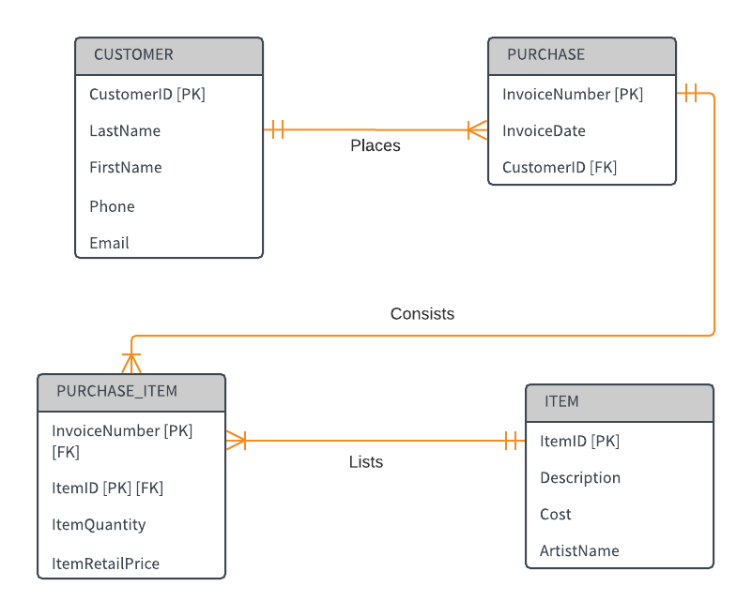

**Section C: Create the Relations**

1. The relations that must be created for this database include background information on the customer (CUSTOMER table), each item in the jewellery store (ITEM table), purchase details bought by a specific customer (PURCHASE table) and purchased items based on an invoice number from the customer (PURCHASE_ITEM). In the CUSTOMER relation, the attributes include specific facts on the customer, by referencing their customer ID (CustomerID), last name (LastName), first name (FirstName), phone number (Phone) and email address (Email). In the ITEM relation, the following attributes specify information on an item located in the store, by mentioning their item ID (ItemID), description (Description), individual cost (Cost) and artist name (ArtistName). In the PURCHASE relation, the attributes encompassing details on the customer purchase include the invoice number (InvoiceNumber), invoice date (InvoiceDate) and customer ID (CustomerID). Finally, the PURCHASE_ITEM relation, the attributes include facts on item being purchased by the customer, by relying on the invoice number (InvoiceNumber), item ID (ItemID), item quantity (ItemQuantity) and item retail price (ItemRetailPrice).
2. In the CUSTOMER table, there is a primary key: customer ID (CustomerID), but there are no foreign keys located in this relation. In the ITEM table, item ID (ItemID) is the primary key, and again there are no foreign keys mentioned in this relation. In the PURCHASE relation, the primary key is the invoice number (InvoiceNumber) and the foreign key is the customer ID (CustomerID) basically referenced from the CUSTOMER table. Finally, the PURCHASE_ITEM relation contains two primary keys: the invoice number (InvoiceNumber) and the item ID (ItemID) and two foreign keys which include the invoice number (InvoiceNumber) and the item ID (ItemID) as well. Basically, the names for relations include CUSTOMER (storing customer data), ITEM (collecting item information), PURCHASE (details on the purchase arranged by the customer) and PURCHASE_ITEM (facts on the item being purchased by the customer).

**Part 2: Build the Tables**

* CUSTOMER (CustomerID, LastName, FirstName, Phone, Email)
* ITEM (ItemID, Description, Cost, ArtistName)
* PURCHASE (InvoiceNumber, InvoiceDate, CustomerID)
* PURCHASE_ITEM (InvoiceNumber, ItemID, ItemQuantity, ItemRetailPrice)

The following primary keys (CustomerID, ItemID and InvoiceNumber) follow the entity integrity rules, since they contain unique values and non-null values for each individual row. According to Figure 1, the constraints declare these columns to be primary keys. The foreign keys, which include the CustomerID from the PURCHASE table (referencing the CUSTOMER table), InvoiceNumber (referencing the PURCHASE table) and ItemID (referencing the ITEM table) from the PURCHASE_ITEM table, follow the referential integrity rules because it includes referenced values from primary keys in other tables from the database.

**Part 3: Populate Tables and Show Contents**

a)

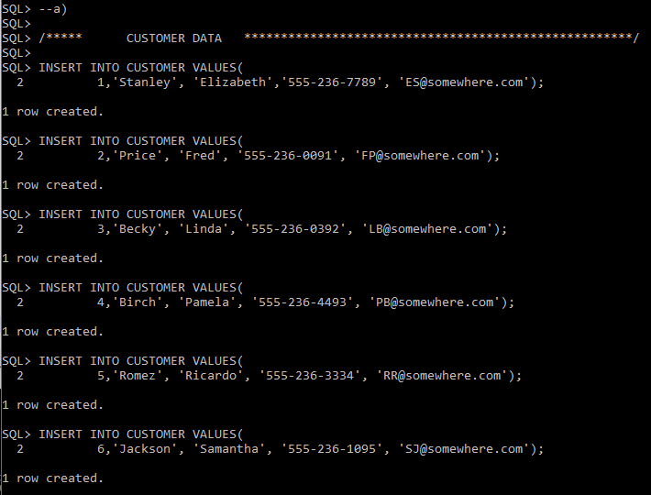

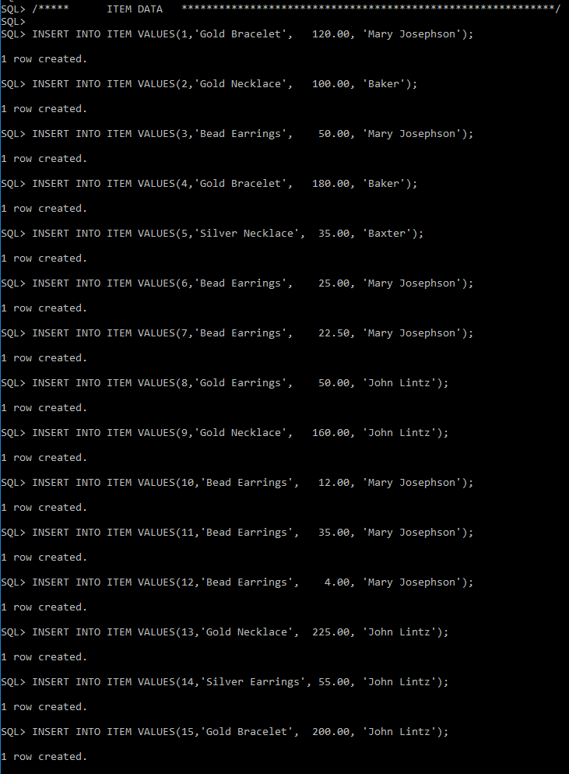

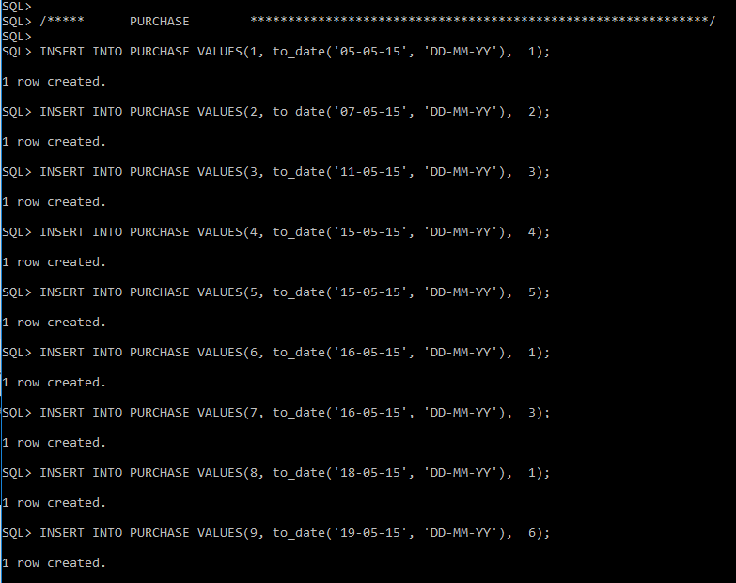

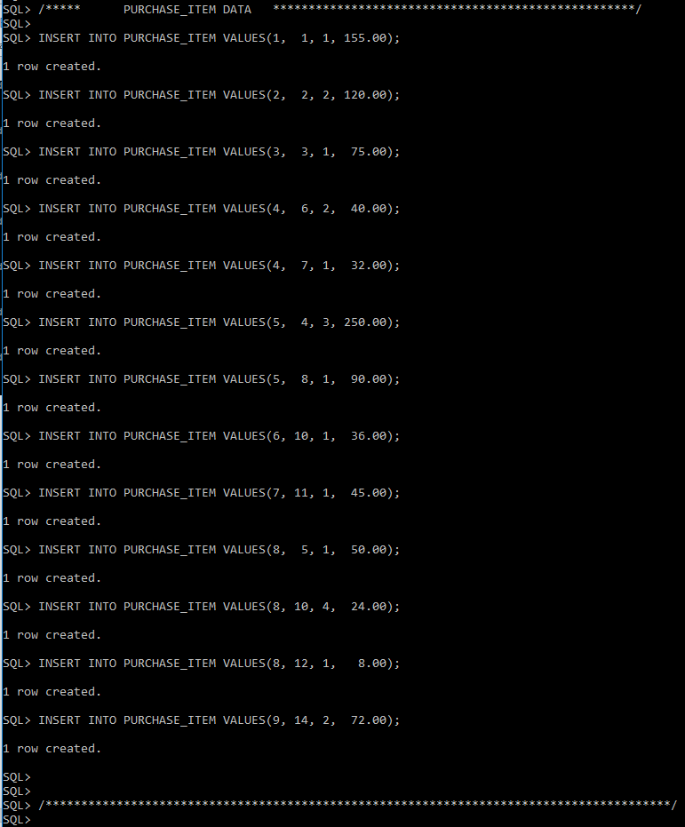

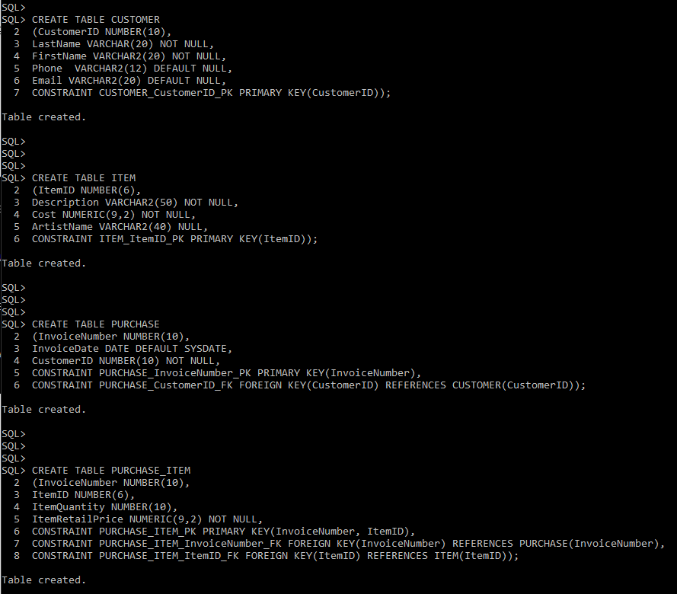

b)

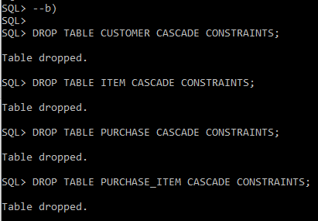

c)

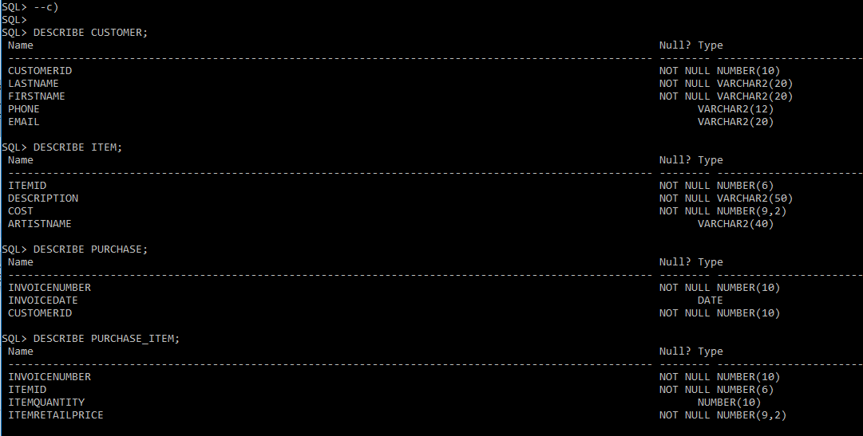

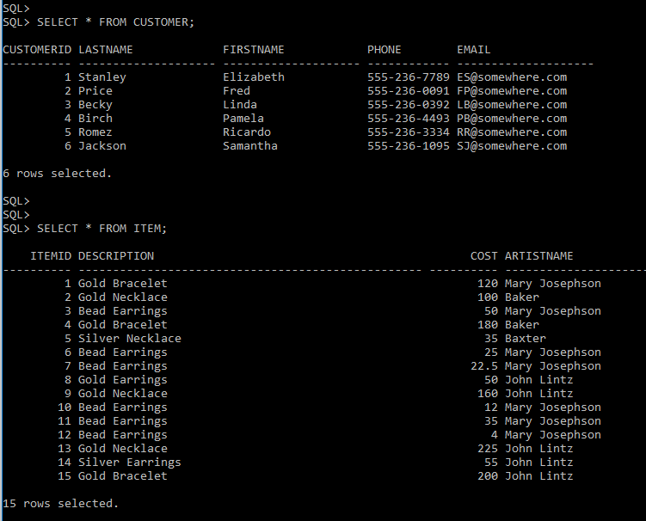

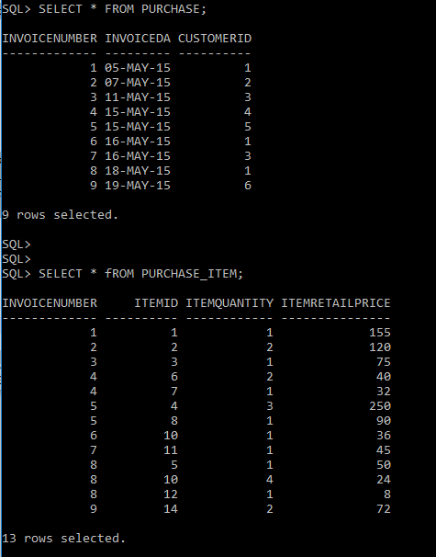

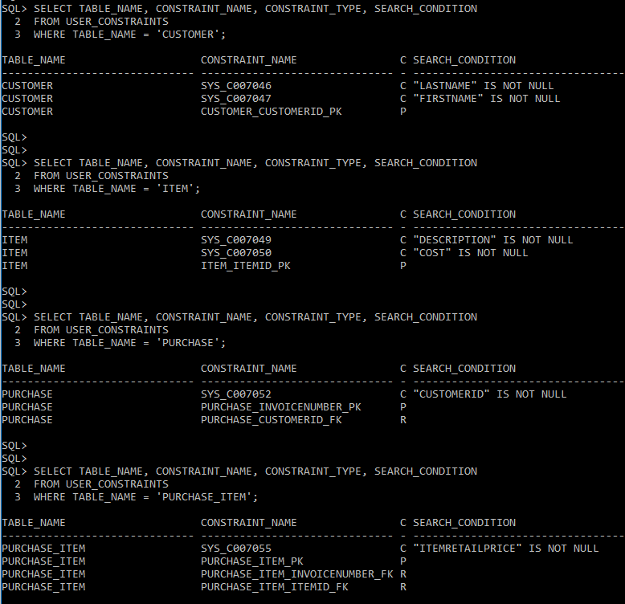

**Part 4: Queries Questions**

